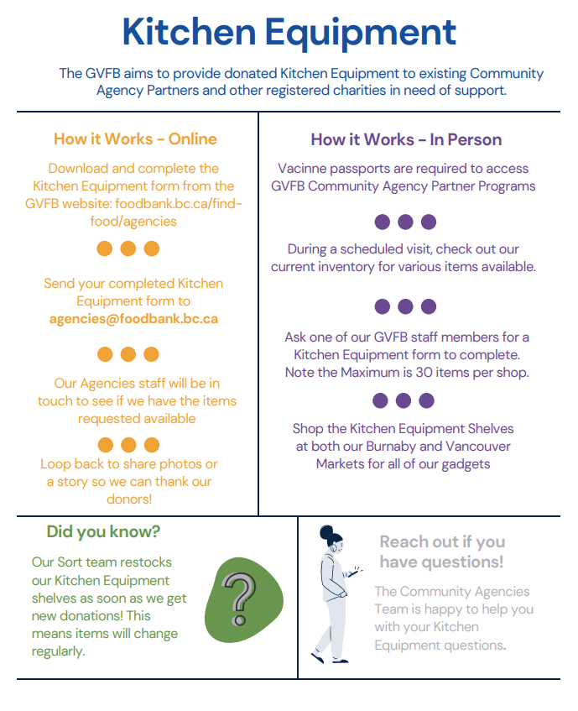

Kitchen Equipment Form

General Information
Organization Name: |  | Click to enter text
Agency Code (GVFB completes): |  |  |  | Click to enter text
Contact Name: | Click to enter text |  |  |  | Phone Number: |  | Click to enter text
Method of distribution |  |  | Click to enter text |  | Date: | Click to enter text

Equipment Provided
GVFB Completes |  |  |  | Item Description |  |  |  | Quantity Quantity
 | KE Code |  |  |  | Click to enter text |  | Click to enter text
 | KE Code |  |  |  | Click to enter text |  | Click to enter text
 | KE Code |  |  |  | Click to enter text |  | Click to enter text
 | KE Code |  |  |  | Click to enter text |  | Click to enter text
 | KE Code |  |  |  | Click to enter text |  | Click to enter text
 | KE Code |  |  |  | Click to enter text |  | Click to enter text
 | KE Code |  |  |  | Click to enter text |  | Click to enter text
 | KE Code |  |  |  | Click to enter text |  | Click to enter text
 | KE Code |  |  |  | Click to enter text |  | Click to enter text
 | KE Code |  |  |  | Click to enter text |  | Click to enter text
 | KE Code |  |  |  | Click to enter text |  | Click to enter text
 | KE Code |  |  |  | Click to enter text |  | Click to enter text
 | KE Code |  |  |  | Click to enter text |  | Click to enter text
 | KE Code |  |  |  | Click to enter text |  | Click to enter text
 | KE Code |  |  |  | Click to enter text |  | Click to enter text
 | KE Code |  |  |  | Click to enter text |  | Click to enter text
 | KE Code |  |  |  | Click to enter text |  | Click to enter text
 |  |  |  |  |  |  | Click to enter text
PLEASE NOTE: There is a maximum of 30 items total per order
Total

