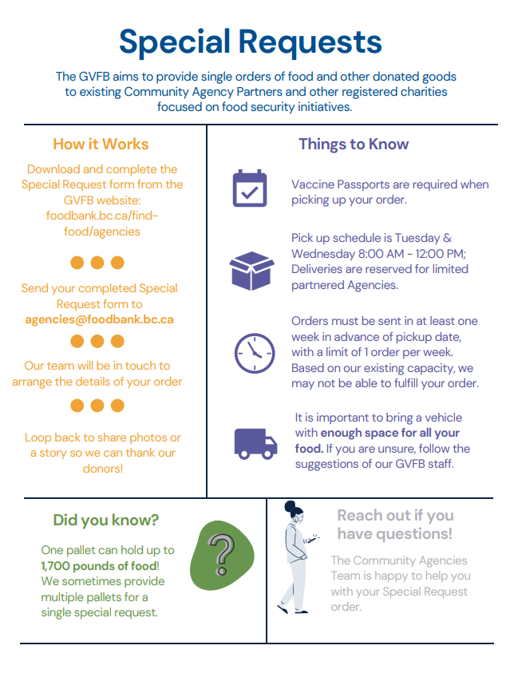

Special Request Form

General Information
Organization Name: |  |  | Click to enter text
Agency Code (GVFB completes): |  |  |  | Click to enter text
Contact Name: |  | Click to enter text |  |  | Phone Number: |  | Click to enter text
Order Date: | Click to enter text |  |  |  | Pick up Date: | Click to enter text
Please provide a short paragraph describing the event or program this order will support:
Click to enter text

Equipment Provided
Quantity |  |  |  | Product Description |  |  |  | Quantity Notes
 | Quantity |  |  |  | Click to enter text |  | Click to enter text
 | Quantity |  |  |  | Click to enter text |  | Click to enter text
 | Quantity |  |  |  | Click to enter text |  | Click to enter text
 | Quantity |  |  |  | Click to enter text |  | Click to enter text
 | Quantity |  |  |  | Click to enter text |  | Click to enter text
 | Quantity |  |  |  | Click to enter text |  | Click to enter text
 | Quantity |  |  |  | Click to enter text |  | Click to enter text
 | Quantity |  |  |  | Click to enter text |  | Click to enter text
 | Quantity |  |  |  | Click to enter text |  | Click to enter text
 | Quantity |  |  |  | Click to enter text |  | Click to enter text
 | Quantity |  |  |  | Click to enter text |  | Click to enter text
 | Quantity |  |  |  | Click to enter text |  | Click to enter text
 | Quantity |  |  |  | Click to enter text |  | Click to enter text
 | Quantity |  |  |  | Click to enter text |  | Click to enter text
 | Quantity |  |  |  | Click to enter text |  | Click to enter text
 | Quantity |  |  |  | Click to enter text |  | Click to enter text
 |  |  |  |  |  |  | Click to enter text
PLEASE NOTE: Specify the quantity and type of food requested.
Total

